SIMATS ENGINEERING
ASSESSMENT TOOL 3

COURSE NAME: CSA16 COURSE CODE: Data Warehousing and Data Mining

COURSE OUTCOME COVERED

CO1: Design data warehouse architectures with appropriate dimensional models for effective decision support systems. BL1,BL2
Assessment Tool Weightage: 30%

QUESTIONS: 2 Total Marks:50

Annexure A

Technical Presentation

Criteria | Technical Content Accuracy(3) | Problem Identification(2.5) | Use of Tools(2) | Communication(1.5) | Professionalism(1) | Total(10)
Weightage | 30% | 25% | 20% | 20% | 10% | 100%
Q1
Q2

Code of Conduct:

I am k Vidyarthi(192311352) (Name / Reg No) certify that this submission is my original work and that I have adhered to the guidelines specified for this assessment.
I understand that any violation of academic integrity rules will result in disciplinary action.

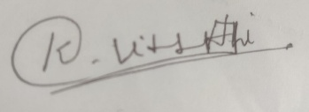

Signature of the student:

